Special Olympics Great Britain
Personal Athlete Profile
Name : Age at Event:
Athlete Contact Number:
Coach:
Emergency Contact Number:

Accredited Programme/Delegation:

Insert Athlete Headshot

Section 1 - Parents, Carers and Club Leads/Coaches:
Following completion of the Athlete Risk assessment and One Page Profile, please add the risk rating to the below areas by shading the boxes by level of risk. For example:
Medical Condition/Emergency
Allergies

Please then complete Section 2 with your athlete.
Low Risk | Medium Risk | High Risk | Critical Risk

Medical Condition/Emergency
Allergies
Dietary
Communication
Sensory
Routine/What is Happening
New Places/Event
Travelling/When in Public
Making the right choices
Absconding/Hiding
Sleeping/Overnight Stays
Self-Care
Mental Health
Self-Harm-Suicidal Thoughts
Abusive Language
Aggressive/Threatening Behaviour
Physical / Violent Behaviour
Physical Intervention
Section 2.
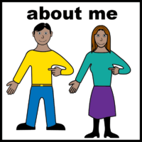
About me:
Athletes, please help your clubs, coaches and the Games Organising Committee get to know you better.
Please give us as much information on the topics below as you can with support from you parents and carers, we have added some questions to help. This will tell us more about how to support you.
If there is section not relevant you can leave it blank or write N/A.
Medical Condition Alert/Emergency:

 | Do you have any medical conditions that may mean you need help right away - i.e. Asthma, Epilepsy, Diabetes etc  Tell us what is important to know about how to help you if this happens – i.e. I will need my inhaler, follow my emergency medication protocol
Allergies
 | Do you have any Allergies conditions that may mean you need help right away - i.e. Nuts  Tell us what is important to know about how to help you if this happens - i.e. I will need my EpiPen, follow emergency medication protocol
Dietary
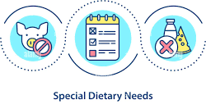 | Do you have any special dietary needs e.g. Halal, Vegetarian?  Does your behaviour get affected by eating certain food types e.g fizzy drinks?  Do you need support to make healthy food choices?  Do you need support with your portion sizes?  What is the best way to support you?
Communication
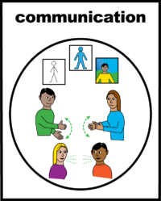 | How do you like to communicate? – i.e verbally, via a communication board, using Makaton etc  Do you need help to communicate? – i.e. limited choices, allowing processing time etc.  Do you have key words or phrases that help / trigger you?
Sensory
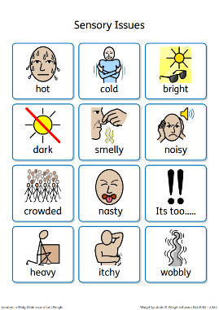 | Do you have any sensory issues/needs? – i.e. depth perception, balance needs, don’t like loud noises, don’t like bright lights, certain textures etc.  How can we support your sensory needs?
Routine / What is Happening
 | Does routine and knowing what is happening help you?  Do you have set routines? - i.e. bedtime  How is it best to support you if plans/your routine changes?
New Places/Event
 | How do you feel when you go to new places you have not been before?  What do you like to know before you go there?  How can we support you in new places?
Travelling/When in Public
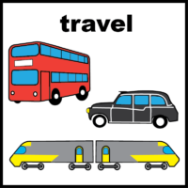 | Have you travelled abroad before?  Have you travelled without your family before?  Do you get homesick?  Do you have any issues with lifts or escalators?  Does travelling make you worry?  What support do you need when you travel?
Making the right choices
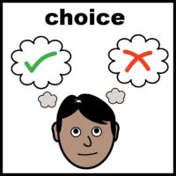 | Are you able to make good/safe choices on your own?  Do you need support to make choices?  How can we support you with making choices?
Absconding / Hiding
 | Have you ever run away from the people that are caring for you?  Have you ever hidden from your carers/family and not told them where you are?  Do you require support to stop you from running away or hiding?
Sleeping / Overnight Stays
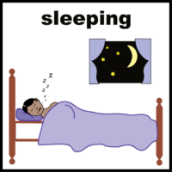 | How are you when sleeping in a new place?  Are you able to share a room?  Do you have any issues at night time? i.e. bed wetting, sleep walking/talking, trouble getting to sleep?  How can we support you when you are staying overnight away from home?
Self-Care
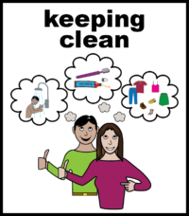 | Do you need help with your self care?  Do you need prompting to shower, brush teeth etc?  Do you need help toileting?
Mental Health
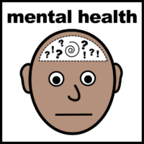 | Do you have any mental health conditions?  Are you receiving any help for your mental health?
Self-Harm-Suicidal Thoughts
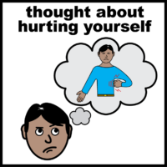 | Have you ever thought about hurting yourself?  If so, what support are you getting to help you?
Abusive Language
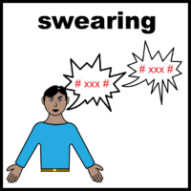 | Do you ever use swear words or bad language when you speak to other people?  What support do you get to help you?
Aggressive/Threatening Behaviour
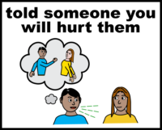 | Do you ever tell someone you will hurt them?  What support do you need to stop this behaviour?
Physical / Violent Behaviour
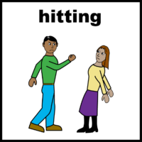 | Do you ever behave violently towards someone else (hitting, kicking, etc).  What support do you need to stop this behaviour?
Physical Intervention
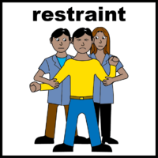 | Do you ever need physical intervention?

Please add this document as a file/photo to your online International Event Registration Form.

