[INSERT IMAGE HERE SPECIFIC TO REGION]

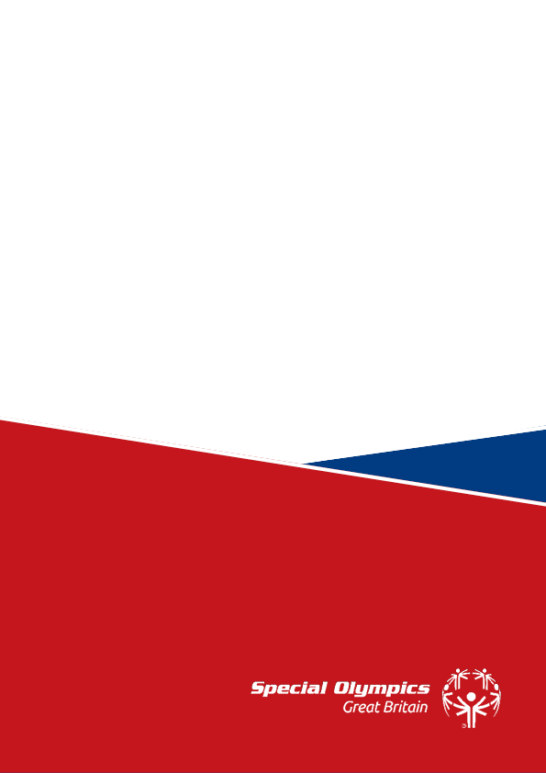

Special Olympics [Region]
Monthly Newsletter/Report

Contents

- About Special Olympics GB
- About the Region [REGION]
- Club Updates this month
- What’s on – opportunities
- SOGB Q&A
- Summary

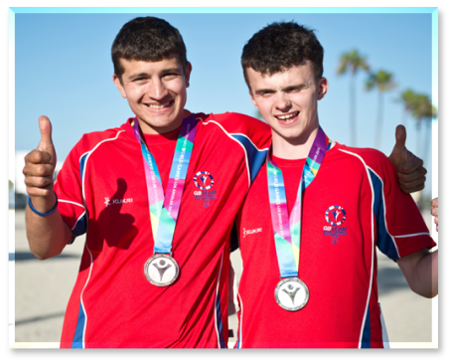
About Special Olympics GB

Special Olympics Great Britain (GB), established in 1978, is a non-profit charity operating across Great Britain and forming a part of the Global Movement Special Olympics. Special Olympics is the largest provider of year-round sports training and athletic competition in both Summer and Winter sports for children and adults of all abilities with intellectual and/or learning disabilities.

Founded in 1968 by Eunice Kennedy Shriver to end discrimination against people with intellectual disabilities, Special Olympics International is now a Global Movement of Inclusion in Action.

As a global movement,
Special Olympics reaches over
3 million athletes, across 207 countries,
with +600,000 volunteers and
+30,000 competitions.


Unlike the Olympics and Paralympics, Special Olympics aims to offer opportunities for athletes of ALL abilities to take part in a range of sport every day of the week, every week of the year.
Membership and participation of all kinds help to ensure the continued growth of Special Olympics, driving forward to achieve a world of inclusion and equality both on and off the field of play.
Together, we want to empower and inspire real and sustainable societal change by raising awareness of intellectual disability, ending discrimination, and building an inclusive world for all. With a competition pathway designed to nurture and progress athletes from local competitions through to accessing elite level competitions, our focus at Special Olympics GB is on ability, not disability, and providing opportunities for our athletes to compete with others at similar levels both at home in Great Britain and beyond.
About Special Olympics GB [REGION]

Number of Accredited Clubs & Programmes: [X]
Number of Athletes: [X]
Number of Volunteers: [X]
IMAGE OF MAIN CONTACT (REGION)
Regional Main Contact: [Enter Details]
Enter some copy here from the Regional Lead directly. This might be a little about them, how they came to be involved in SOGB and what SOGB means to them. It might also include information about their role, what they are able to support with and how to engage with them either directly or via meetings.

About the region
This could be more general information about the region – such as clubs/sports, or history, or future development – anything you like.

[MONTH] Regional Updates
This section might include:
- Specific club updates/ per club?
- Highlights/ Spotlights from clubs/ best practice
- Highlights/Spotlights for volunteers and athletes and achievements
- Upcoming competitions, events, etc.
- Any other updates relevant in the region?

What’s on – Opportunities
This section can be created collaboratively with the regional lead(s) and SOGB to share upcoming opportunities/activities, such as:
- Webinars
- Working Group activities
- Athlete Leadership opportunities
- Opportunities to engage with Sports development/ national sports advisors
- Opportunities to engage with corporate partner work
- Opportunities to engage with third parties/ National Governing Bodies per sport plans (eg. Disability Snowsport UK email I sent recently?)
- Upcoming processes (eg. Accreditation, invoicing, etc.)
- Training & Education opportunities (eg. Toyota Coaching Grant or other opportunities)
- Anything else specifically in the region?
- Wider sector key information eg. Activity Alliance Surveys, etc.

Special Olympics GB Q&A
This section can be a place where clubs can pose questions to the regional lead or SOGB team members that can be answered here, allowing for members to get access to this information where it might be helpful?

Summary

Here is just an opportunity to summarise the key information in this document to make it easier then for club leads to disseminate information in their local clubs directly if needed.

